Neuronal Oscillations on Evolving Networks: Dynamics, Damage, Degradation, Decline, Dementia, and Death, A Goriely, E Kuhl, and C Bick, Physical Review Letters, 125:128102 (2020)

1. Identify the key neuroscience questions addressed by the paper and how the modelling addresses them.

- Alzheimer’s or Parkinson’s show characteristic degradation of structural brain networks.

- gamma activity related to Alzheimer’s disease

* damage does not slow the disease propagation as damage is delayed with respect to seeding?
* temporal lobe is one of the first to see alteration in brain dynamics
* Elucidate the interplay between network adaptation and spreading

1. What are the key mechanisms included in the models? Can you relate the models or aspects of them to other mathematical models you have seen already?

- The accumulation of toxic proteins

- Evolving brain connectome (changes in the network dynamics)

- degradation of cognitive functions (model the progression in terms of couple physical process

Mathematical models:

(Transport, aggregation, damage and oscillations)

* Supercritical Hopf bifurcation model for Wilson Cowan like model
* Biomarkers: Metastability index (Kuramoto order parameter) / Amplitude envelope (average oscillatory activity)

“disease progression through the brain, structural damage created by the disease, and dynamic changes from damage with the associated functional loss.” (Goriely et al., 2020, p. 1)

1. What are the two core types of model / sub-systems that are studied? What timescales do they operate over?

* Non-linear reaction-diffusion transport process that yields an evolving brain connectome characterised by weighted edges ( spatiotemporal evolution of the disease)
* Neuronal-mass model evolves on top of it ? (how it affects basic cognitive functions?)

Timescales:

Multiple temporal scales – years for the disease and seconds for the resting-state dynamics

B. How are they coupled?

The physical damage to the brain and neural dynamics are coupled as they interact on the same connectome given by the following equations:

$$\dot{c_{k}}=−\sum_{j=1}^{N}{L_{kj}}c_{j}+αc_{k}\left(1−c_{k}\right), k=1,…,N,$$ (1)

$$\dot{q_{k}}=βc_{k}\left(1−q_{k}\right), q_{k}\left(0\right)=0, k=1,…,N,$$ (2)

$$\dot{w_{kj}}=−γw_{kj}\left(q_{k}+q_{j}\right), k,j=1,…,N,$$ (3)

The above systems form a closed system of 2N+M ODEs.

1. What does each figure show? What are the key results in the paper?

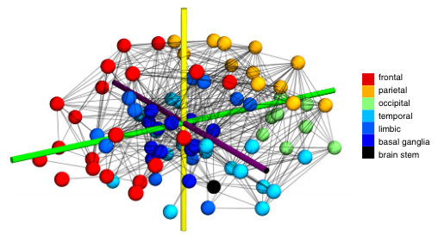

Each node is associated with a particular brain region corresponding to frontal, parietal, temporal, occipital lobes, the limbic area, the basal ganglia, and the brain stem.

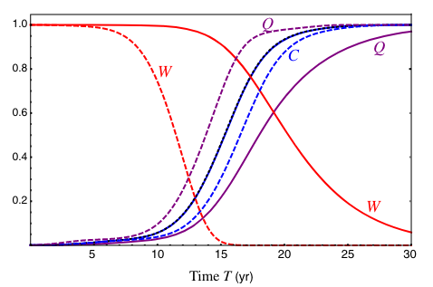

The black dotted curve (superimposed by solid blue curve) is the average concentration in the absence of damage (beta=0, gamma=0). The solid curve is in the case of severe damage (here, beta=0.25, gamma=0.125). For unrealistic values of beta=4, gamma=2, there is a reduction in 99% of all weights after 15yr. The delay in the evolution of concentration is only a year ($$α$$ =0.75, $$ρ$$ = 0.01 mm/yr ) What are dotted and solid Voilet curves though?

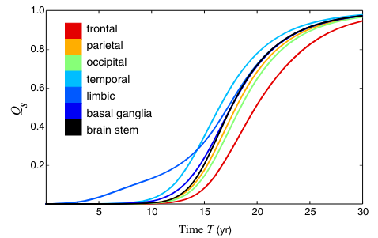

Evolution of samage in different brain regions originating from the limbic region and then moves to the temporal lobe, the basal ganglia, and the parietal and occipital lobes before invading all cortical areas.

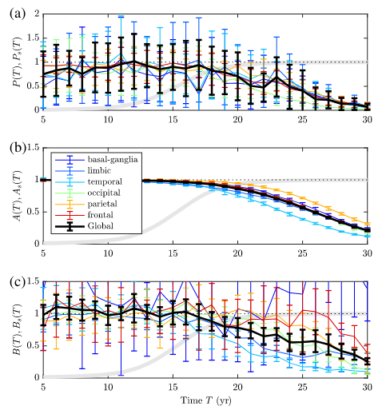

The stability of the dynamic biomarkers upto year 10 followed by a rapid decline after year 16. A) Power in the Gamma band (PSD of the signal) B) Oscillation mean amplitude. C) Metastability (mean variability) indicating nonstationary brain dynamics.

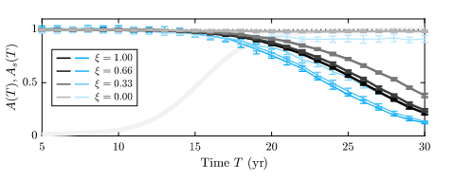

Oscillation amplitudes (mean) at the global level (gray), temporal lobe (blue) with the homeostasis parameter. C(T) is given by solid gray line. Why is it parallel to x-axis?

1. Are there other relevant works to consider, either previous work on the topic or work that follows this paper?

* Static properties of the network [7], Synchronization [1]
* An analysis of a mesoscale mouse connectome with information on directionality (less viable for the human brain) reveals that asymmetry delays significantly the onset of the disease but preserves its main characteristics (see Supplemental Material [4]). [2] [3]
* Other models for whole-brain dynamics focus on different features of brain dynamics [5] and relate to microscopic neural properties [6]

To Do:

Please can you coordinate a response to Q5 and then embed the questions below and initial responses in a shared document – for example, this would mean from Q3 and Q4 we could see and share what we learnt today about the key mechanisms in the model(s) and the different timescales involved.

* Get the connectome data, find out a bit more about it, whether it has been updated, whether there are other similar connectomes that could be used, etc.
* Start implementing the protein concentration / damage / weights model. Think about the data structures required. Your state vector will be something like: (c1,c2,c3,…,cN,q1,q2,q3,…,qN,w1,w2,w3,…,wM) where N is the number of nodes and M is the number of non-zero connections (M<=M^2). This requires a map from (1,2,3,…,M) to pairs of nodes (this map is actually the connectome, each row of the connectome is one connection between two nodes.

Question: is the connectivity directed (e.g. stronger in one direction than the other, so w_{jk} != w_{kj} ) or not (equal in either direction, so w_{jk} = w_{kj})? What would this mean?

* Start implementing the resting state neural mass model, assuming the weights are fixed at the connectome values.

References

[1] P. J. Uhlhaas and W. Singer, Neuron 52, 155 (2006).

[2] M. X. Henderson, E. J. Cornblath, A. Darwich, B. Zhang, H. Brown, R. J. Gathagan, R. M. Sandler, D. S. Bassett, J. Q. Trojanowski, and V. M. Lee, Nat. Neurosci. 22,1248(2019)

[3] M. X. Henderson, S. Sedor, I. McGeary, E. J. Cornblath, C. Peng, D. M. Riddle, H. L. Li, B. Zhang, H. J. Brown, M. F. Olufemi et al., Neuron 105, 822 (2020).

[4] See Supplemental Material at http://link.aps.org/supplemental/ 10.1103/PhysRevLett.125.128102 for further model analysis and details on the numerics.

[5] M. Breakspear, Nat. Neurosci. 20, 340 (2017).

[6] C. Bick, M. Goodfellow, C. R. Laing, and E. A. Martens, J. Math. Neurosci. 10, 9 (2020).

[7] C. J. Stam, B. Jones, G. Nolte, M. Breakspear, and P. Scheltens, Cereb. Cortex 17, 92 (2006).